

GIS工程与开发
课程作业提交

作业周次： | 4
学生姓名： | 云天浩
学 号： | 2024104049
专业班级： | 01
提交日期： | 4/17

第一部分：源代码

代码整合·更新Xpolygon，Xline的方法解决多部件（Multi-Part）要素的错误拆分
优化更新Xshapefile和Xpolygon，Xline的绘制方法，以及Distance判断方法，保留之前的高亮绘制方法
public class XPoint : XSpatial
{
public XPoint(XVertex v) : base(new List<XVertex> { v }) { }
public override void draw(Graphics g, XView v)
{
Point sp = v.ToScreenPoint(centroid);
if (IsSelected)
g.FillEllipse(Brushes.Yellow, sp.X - 5, sp.Y - 5, 10, 10);
g.FillEllipse(Brushes.Red, sp.X - 3, sp.Y - 3, 6, 6);
}
}

class XLine : XSpatial
{
public bool ShowNodes = false;
public double Length => XTools.CalculateLength(vertexes);
public XLine(List<XVertex> _vertexes) : base(_vertexes) { }
public override double Distance(XVertex vertex)
{
double distance = Double.MaxValue;
for (int i = 0; i < vertexes.Count - 1; i++)
{
distance = Math.Min(XTools.DistanceBetweenPointAndSegment(
vertexes[i], vertexes[i + 1], vertex),
distance);
}
return distance;
}

public override void draw(Graphics graphics, XView view)
{
if (vertexes.Count < 2) return;
Point[] points = new Point[vertexes.Count];
for (int i = 0; i < vertexes.Count; i++)
{
points[i] = view.ToScreenPoint(vertexes[i]);
}

if (IsSelected)
{
using (Pen highlightPen = new Pen(Color.Yellow, 5))
graphics.DrawLines(highlightPen, points);
}
using (Pen linePen = new Pen(Color.Blue, 2))
{
graphics.DrawLines(linePen, points);
}
if (ShowNodes)
{
using (Pen markPen = new Pen(Color.Red, 2))
{
foreach (Point p in points)
{
graphics.DrawLine(markPen, p.X - 8, p.Y, p.X + 8, p.Y);
graphics.DrawLine(markPen, p.X, p.Y - 8, p.X, p.Y + 8);
}
}

}
}
}

public class XPolygon : XSpatial
{
public double Area;
public XPolygon(List<XVertex> _vertexes) : base(_vertexes)
{
Area = XTools.CalculateArea(_vertexes);
}

public bool Contains(XVertex vertex, out bool inside)
{
int count = 0;
inside = true;
for (int i = 0; i < vertexes.Count; i++)
{
//满足情况3
if (vertexes[i].IsSame(vertex))
{
inside = false;
return true;
}
//由序号为i及next的两个节点构成一条线段，一般情况下next为i+1，
//而针对最后一条线段，i为vertexes.Count-1，next为0
int next = (i + 1) % vertexes.Count;
//确定线段的坐标极值
double minX = Math.Min(vertexes[i].x, vertexes[next].x);
double minY = Math.Min(vertexes[i].y, vertexes[next].y);
double maxX = Math.Max(vertexes[i].x, vertexes[next].x);
double maxY = Math.Max(vertexes[i].y, vertexes[next].y);
//如果线段是平行于射线的。
if (minY == maxY)
{
//满足情况2
if (minY == vertex.y && vertex.x >= minX && vertex.x <= maxX)
{
inside = false;
return true;
}
//满足情况1或者射线与线段平行无交点
else continue;
}
//点在线段坐标极值之外，不可能有交点
if (vertex.x > maxX || vertex.y > maxY || vertex.y < minY) continue;
//计算交点横坐标，纵坐标无需计算，就是vertex.y
double X0 = vertexes[i].x + (vertex.y - vertexes[i].y) *
(vertexes[next].x - vertexes[i].x) / (vertexes[next].y - vertexes[i].y);
//交点在射线反方向，按无交点计算
if (X0 < vertex.x) continue;
//交点即为vertex，且在线段上
if (X0 == vertex.x)
{
inside = false;
return true;
}
//射线穿过线段下端点，不记数
if (vertex.y == minY) continue;
//其他情况下，交点数加一
count++;
}
return count % 2 != 0;
}

public override double Distance(XVertex vertex)
{
bool inside;
if (Contains(vertex, out inside))
{
if (inside) return -1;
else return 0;
}
else
{
List<XVertex> vs = new List<XVertex>();
vs.AddRange(vertexes);
vs.Add(vertexes[0]);
XLine line = new XLine(vs);
return line.Distance(vertex);
}
}

public override void draw(Graphics g, XView view)
{
Point[] points = view.ToScreenPoints(vertexes).ToArray();
Color fillColor = IsSelected ? Color.FromArgb(50, Color.Yellow) : Color.FromArgb(50, Color.Orange);
using (SolidBrush brush = new SolidBrush(fillColor))
g.FillPolygon(brush, points);

using (Pen borderPen = IsSelected ? new Pen(Color.Red, 3) : new Pen(Color.Black, 1))
{
g.DrawPolygon(borderPen, points);
}
}
}

更新选择要素方法
在之前选择要素功能的前提下，新增在查看模式下ctrl框选要素，更新Xselect类，并更新SelectFeaturesByExtent和SelectFeaturesByVertex
修复各种模式切换中的bug，具体方法有设计清空要素方法和重新设计if判断
private void Form1_MouseClick(object sender, MouseEventArgs e)
{
if (e.Button == MouseButtons.Right)
{
// 如果在测量中途右键，清空第一点，不生成图层
if (currentMouseTool == XMouseTool.measure && firstVertex != null)
{
firstVertex = null;
Invalidate(); // 清除橡皮筋预览线
return;
}

// 退出工具模式
currentMouseTool = XMouseTool.none;
this.Cursor = Cursors.Default;
Invalidate();
}

// 左键点击：执行原有逻辑
if (e.Button == MouseButtons.Left)
{
XVertex mouseMapV = view.ToMapVertex(e.Location);
switch (currentMouseTool)
{
case XMouseTool.measure:
MeasureLogic(mouseMapV);
break;
}
}
}
private void Form1_MouseDown(object sender, MouseEventArgs e)
{
if (e.Button != MouseButtons.Left) return;
MouseDownLocation = e.Location;
MouseMovingLocation = e.Location;

if (currentMouseTool == XMouseTool.identify && Control.ModifierKeys == Keys.Control)
{
currentMouseAction = XExploreActions.identifybybox;
}
else if (Control.ModifierKeys == Keys.Shift)
{
currentMouseAction = XExploreActions.zoominbybox;
}
else
{
currentMouseAction = XExploreActions.pan;
}
}

private void Form1_MouseMove(object sender, MouseEventArgs e)
{
MouseMovingLocation = e.Location;
if (currentMouseTool == XMouseTool.measure && firstVertex != null)
{
Invalidate(); // 强制触发 Paint 事件
}
if (currentMouseAction == XExploreActions.zoominbybox ||
currentMouseAction == XExploreActions.pan)
{
Invalidate();
}
if (currentMouseAction == XExploreActions.identifybybox)
{
Invalidate();
}
}

private void Form1_MouseUp(object sender, MouseEventArgs e)
{
XVertex mouseMapV = view.ToMapVertex(e.Location);

if (currentMouseAction == XExploreActions.identifybybox)
{
IdentifyLogic(mouseMapV, e.Location);
}
else if (currentMouseAction == XExploreActions.pan)
{
// 只有当鼠标真的移动了才平移，否则视为普通点击
if (MouseDownLocation != e.Location)
{
XVertex v1 = view.ToMapVertex(MouseDownLocation);
view.OffsetCenter(v1, mouseMapV);
}
else if (currentMouseTool == XMouseTool.identify)
{
// 如果没动鼠标，且是查看工具，则执行单点选择
IdentifyLogic(mouseMapV, e.Location);
}
}
// 3. 拉框放大
else if (currentMouseAction == XExploreActions.zoominbybox)
{
XVertex v1 = view.ToMapVertex(MouseDownLocation);
view.Update(new XExtent(v1, mouseMapV), ClientRectangle);
}

currentMouseAction = XExploreActions.noaction;
UpdateMap();
}
private void IdentifyLogic(XVertex mouseMapV, Point mouseScreenP)
{
ClearSelection(); // 清理旧选择

List<XFeature> selectedFeatures = new List<XFeature>();

if (currentMouseAction == XExploreActions.identifybybox)
{
XVertex v1 = view.ToMapVertex(MouseDownLocation);
XExtent boxExtent = new XExtent(v1, mouseMapV);
selectedFeatures = XSelect.SelectFeaturesByExtent(boxExtent, layers);
}
else
{
// 单点点选
XFeature hit = XSelect.SelectFeaturesByVertex_Message(mouseMapV, layers, view.ToMapDistance(5));
if (hit != null) selectedFeatures.Add(hit);
}

// 渲染结果
if (selectedFeatures.Count > 0)
{
foreach (var f in selectedFeatures) f.IsSelected = true;

// 绑定第一个要素的所有属性
XFeature first = selectedFeatures[0];
XVectorLayer ownerLayer = null;
foreach (var ly in layers)
{
if (ly.Features.Contains(first))
{
ownerLayer = ly;
break;
}
}
DataTable dt = new DataTable();
dt.Columns.Add("属性名");
dt.Columns.Add("值");

for (int i = 0; i < ownerLayer.Fields.Count; i++)
{
string fieldName = ownerLayer.Fields[i].name;
object val = first.attribute.GetValue(i);

if (val.ToString() == "No Attr") continue;
dt.Rows.Add(fieldName, val.ToString());
}

dgvAttributes.DataSource = dt;

// 3. 计算浮窗位置，防止超出屏幕右侧或下方
int posX = mouseScreenP.X + 15;
int posY = mouseScreenP.Y + 15;
if (posX + pnlInfo.Width > this.ClientSize.Width) posX = mouseScreenP.X - pnlInfo.Width - 15;
if (posY + pnlInfo.Height > this.ClientSize.Height) posY = mouseScreenP.Y - pnlInfo.Height - 15;

pnlInfo.Location = new Point(posX, posY);
pnlInfo.Visible = true;
pnlInfo.BringToFront();
}
else
{
pnlInfo.Visible = false;
}

UpdateMap();
}

框选更新paint方法
实现具体框选
private void Form1_Paint(object sender, PaintEventArgs e)
{
if (backwindow == null) return;

// 只有在平移时需要特殊处理位移，其他情况都画在 0,0
if (currentMouseAction == XExploreActions.pan)
{
e.Graphics.DrawImage(backwindow,
MouseMovingLocation.X - MouseDownLocation.X,
MouseMovingLocation.Y - MouseDownLocation.Y);
}
else
{
e.Graphics.DrawImage(backwindow, 0, 0);
}

//绘制测距预览线
if (currentMouseTool == XMouseTool.measure && firstVertex != null)
{
Point pStart = view.ToScreenPoint(firstVertex);
Point pEnd = MouseMovingLocation;
using (Pen rubberPen = new Pen(Color.Blue, 1.5f))
{
rubberPen.DashStyle = System.Drawing.Drawing2D.DashStyle.Dash;
e.Graphics.DrawLine(rubberPen, pStart, pEnd);
}

// 建议：实时显示一下当前移动的距离，体验更好
double curDist = firstVertex.Distance(view.ToMapVertex(pEnd));
e.Graphics.DrawString($"{curDist:F2}", this.Font, Brushes.Blue, pEnd.X + 10, pEnd.Y + 10);
}

if (currentMouseAction == XExploreActions.zoominbybox || currentMouseAction == XExploreActions.identifybybox)
{
int x = Math.Min(MouseDownLocation.X, MouseMovingLocation.X);
int y = Math.Min(MouseDownLocation.Y, MouseMovingLocation.Y);
int width = Math.Abs(MouseDownLocation.X - MouseMovingLocation.X);
int height = Math.Abs(MouseDownLocation.Y - MouseMovingLocation.Y);
using (Pen boxPen = new Pen(Color.Red, 2))
{
e.Graphics.DrawRectangle(boxPen, x, y, width, height);
}
}
}

第二部分：系统运行截图

运行截图一
点击要素更新，用pannel浮窗展示属性，选择要素实现高亮
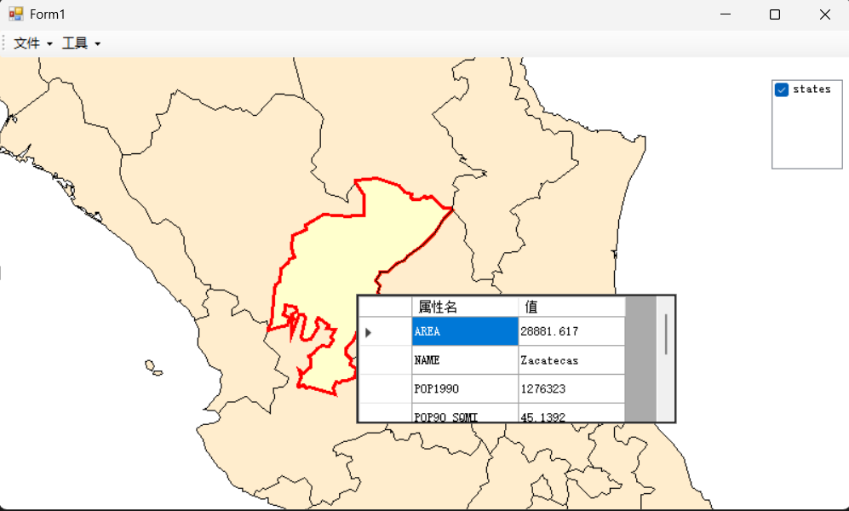
输出观察，选中三个，取距离最近的或者直接在多边形内部的
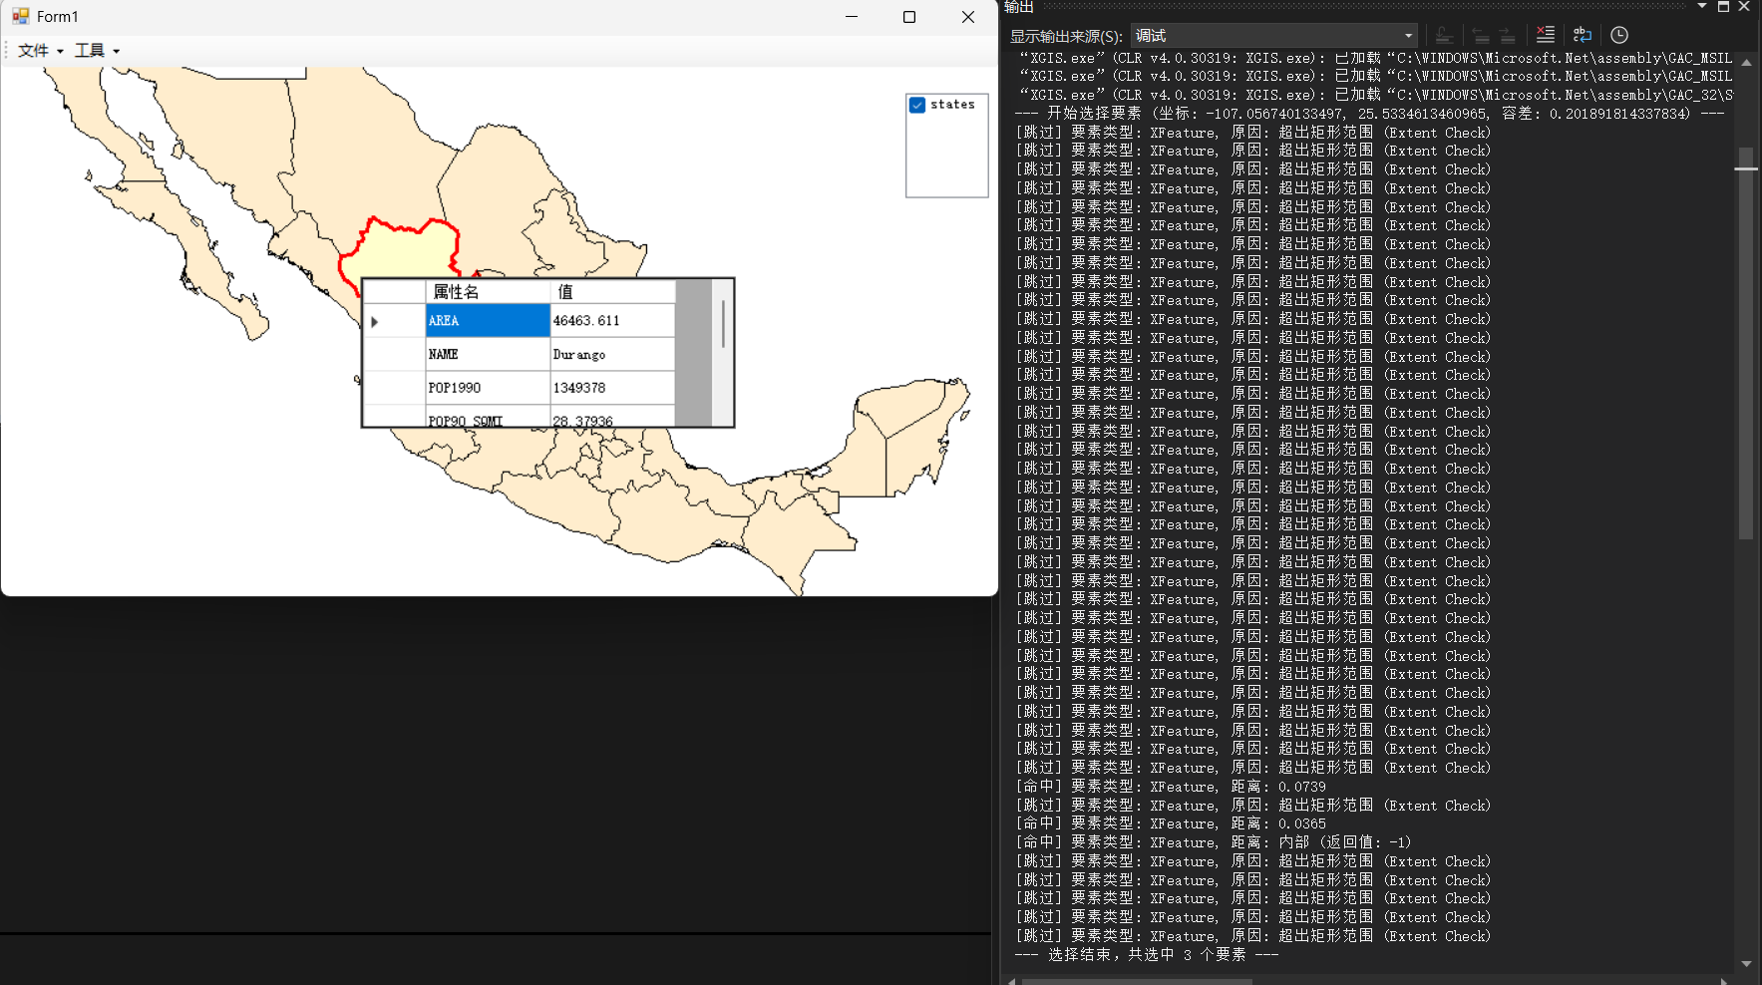
点和线的选择测试
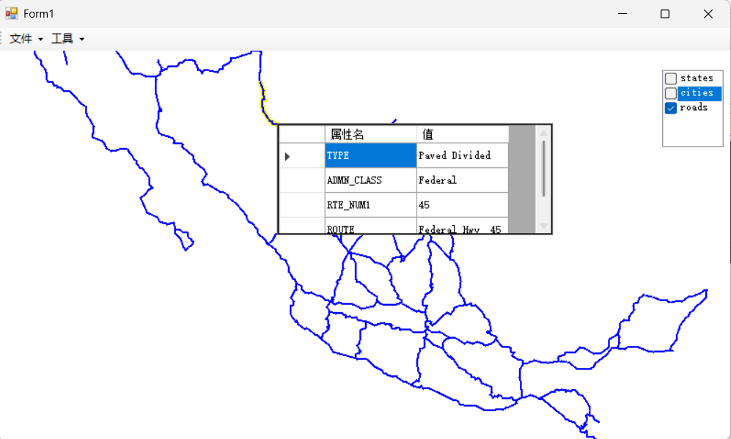
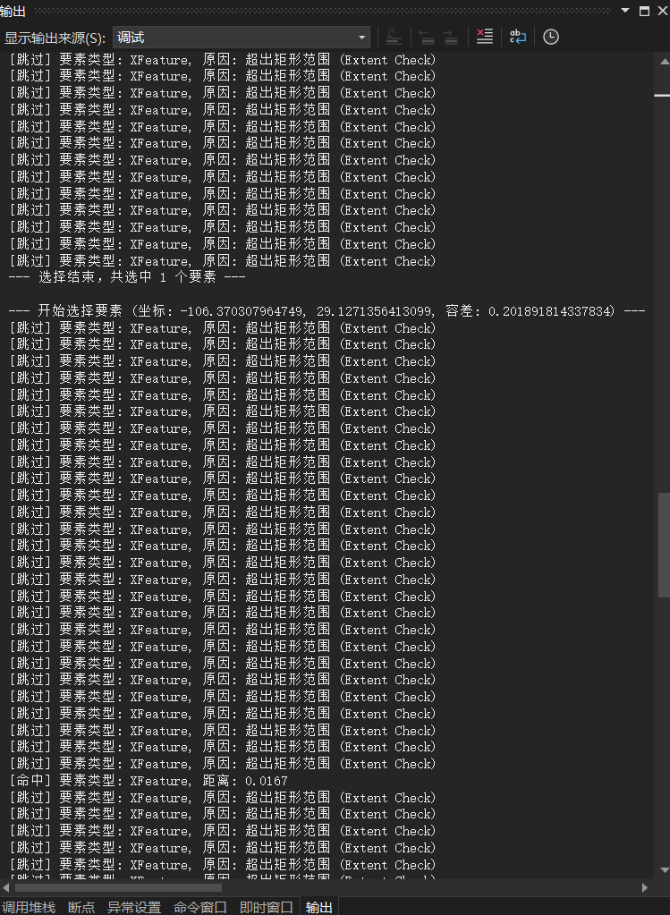

拉框选择展示
